### Using Bluetooth APP

**Android system:**

1. Click the Tank\_Car compression package to direct install the Tank\_Car APP; installed well, appear the icon below on your mobile phone:

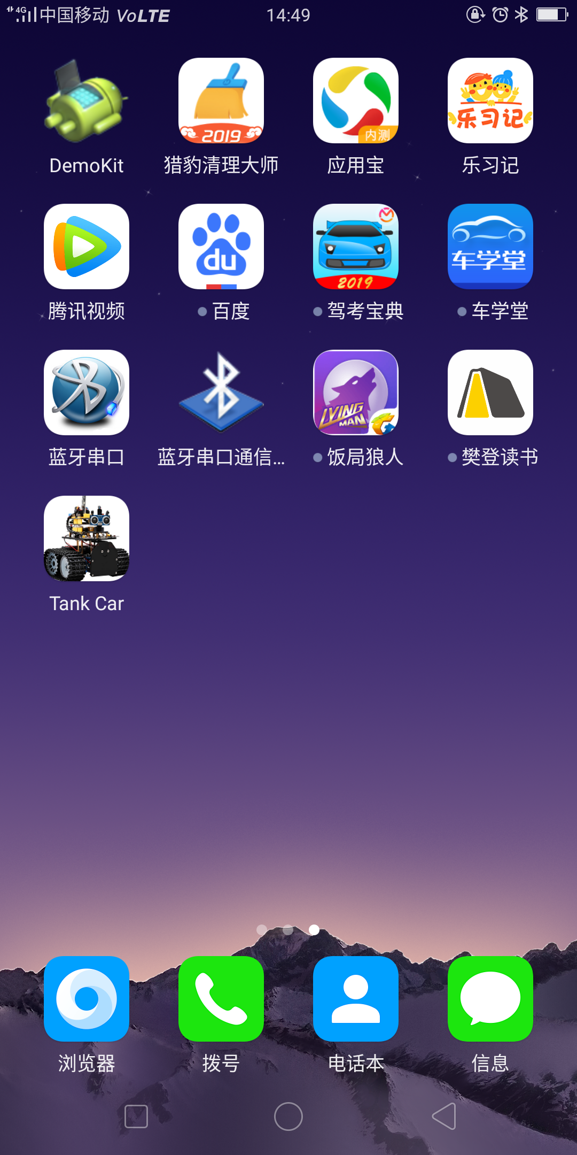

Download the Tank\_Car package from the link below:  
<https://fs.keyestudio.com/KS0428-APP>

Or you can download the keyestudio Tank\_Car APP direct from the Google Play:

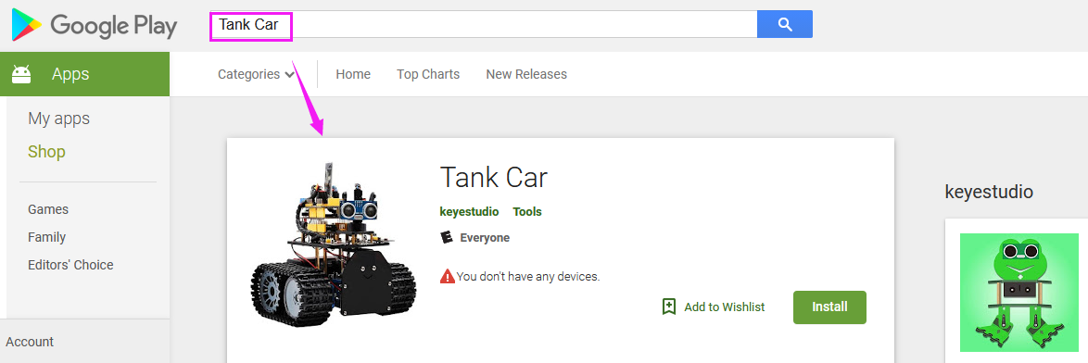

1. Tap the Tank\_Car icon to enter the Bluetooth APP. As shown below.

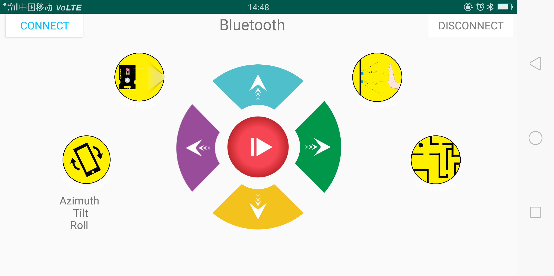

1. Done uploading the code to UNO R3 board, connect the Bluetooth module, the LED on the Bluetooth module will flash.   
   Then tap the option CONNECT on the APP, searching the Bluetooth.

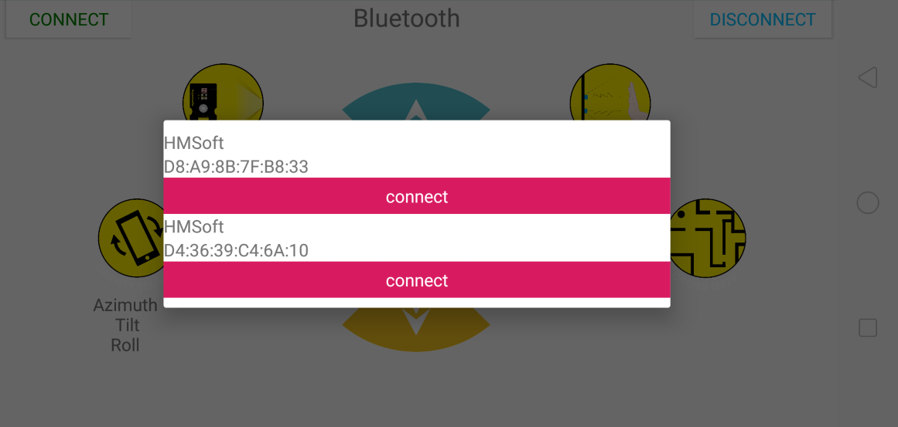

1. Click to connect the Bluetooth. HMSoft connected, Bluetooth LED will turn on normally.

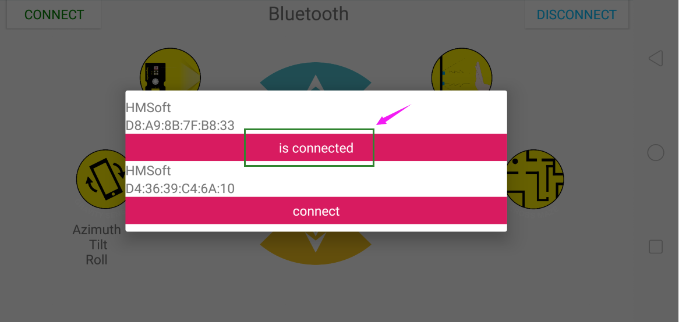

1. Tap the button , 8x16 LED panel will display the front icon. Release the button, display the “STOP”.

**Below is Tank Robot Bluetooth APP interface and we have listed out what function of each key does:**



|  |  |  |
| --- | --- | --- |
| **Button** | **Function** | |
| Screenshot_2019-06-17-08-21-55-51 | pair and connect HM-10 Bluetooth module | |
| Screenshot_2019-06-17-08-21-55-51 | enter Bluetooth control interface | |
| Screenshot_2019-06-17-08-21-55-51 | disconnect the Bluetooth | |
| Screenshot_2019-06-21-14-48-54-58 | **Control character** | **Function** |
| Press: F  Release: S | Press the button, robot goes front; release to stop |
| Screenshot_2019-06-21-14-48-54-58 | Press: B  Release: S | Press the button, robot goes back; release to stop |
| Screenshot_2019-06-21-14-48-54-58 | Press: L  Release: S | Press the button, robot rotates to left; release to stop |
| Screenshot_2019-06-21-14-48-54-58 | Press: R  Release: S | Press the button, robot rotates to right; release to stop |
| Screenshot_2019-06-21-14-48-54-58 | Click to send：S | Stop |
| Screenshot_2019-06-21-14-48-54-58 | Click to send “X” | Start light follow function; click Stop to exit |
| Screenshot_2019-06-21-14-48-54-58 | - | Click to start the mobile posture control; click again to exit |
| Screenshot_2019-06-21-14-48-54-58 | Click to send “Y” | Start ultrasonic follow function; click Stop to exit |
| Screenshot_2019-06-21-14-48-54-58 | Click to send “U” | Start ultrasonic avoiding function; click Stop to exit |